**Overview**

In this exercise you will perform the initial server migrations to Azure that are possible using Azure Migrate. As Server 2003 is not capable of a migration using Azure Migrate we will review this at a later stage.

This exercise is spilt into two areas, migration and post migration.

**Easter Eggs:-**

1. If SQL RDP allow connections isn't enabled the VM will migrate but not be accessible
2. If Ubuntu static IP hasn't been changed, it will be same as above
3. If SQL Windows Firewall for tcp/1433 has not been changed, it is subnet restricted to the hyper-v LAB

**Migration steps**

Review Azure Migrate options to confirm all are connect for each VM that will be migrated

* Correct Subnet
* Static IP on VM
* Correct VM sizing
* Managed Disk enabled

Steps on how to migrate a VM

Review compute & network

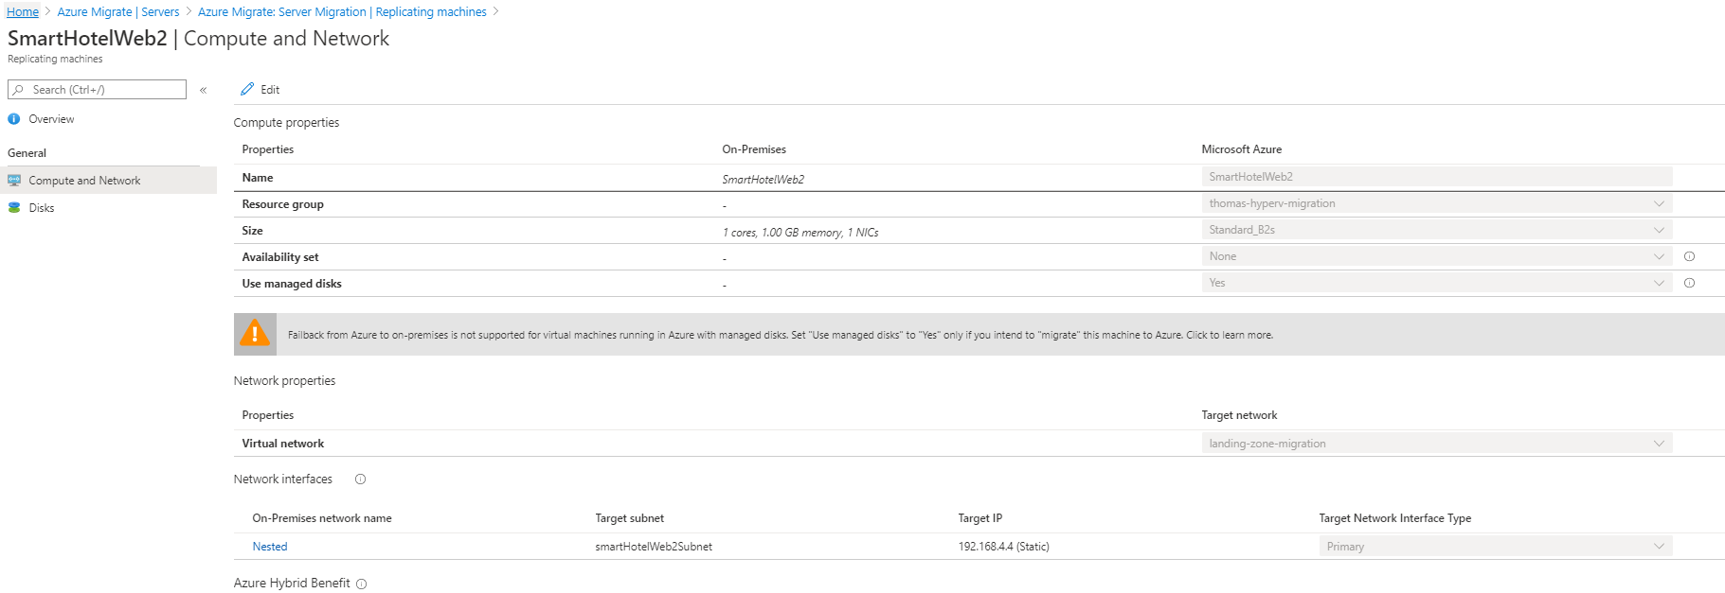

Select migrate -> yes shutdownVM

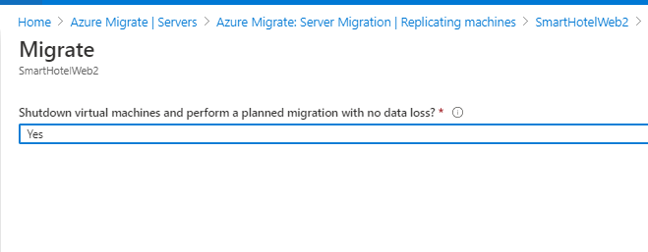

**Required changes to get application to work when migrated**

**UbuntuWAF –**

Ensure the static IP allocation is removed

Configured with static IP in /etc/network/interfaces

Change to:-

auto eth0

iface eth0 inet dhcp

If brought across without this, will become inaccessible

**Smarthotelweb1 –**

C:\inetpub\SmartHotel.Registration\web.config

Change **<endpoint address=**[**http://10.2.2.4:2901/Service.svc**](http://10.2.2.4:2901/Service.svc)to new IP of SmartHotelWeb2

IISReset

**SmartHotelWeb2 -** 192.168.4.4

C:\inetpub\SmartHotel.Registration.Wcf\web.config

Change **<add name="DefaultConnection" connectionString="Server=tcp:10.2.2.6,1433** to new IP of SmartHotelSQL1

IISReset

**SmartHotelSQL1 -** 192.168.5.5

**Post-Migration tasks to be completed on each VM**

1. CMD:- “ipconfig /registerdns”
2. Check VM disks, ensure they are standard SSD
3. Assign correct Application Security Groups
4. Ensure VM has Static IP
5. Boot Diagnostics setup
6. VM has been assigned NSG on NIC
7. Configure log analytics agent to the new workspace solution
8. Malware/AV extension installed (Microsoft Antimalware)

Application, ensure the valid is still appearing and available from Hyper-V host. Screenshot as below Is the example web page.

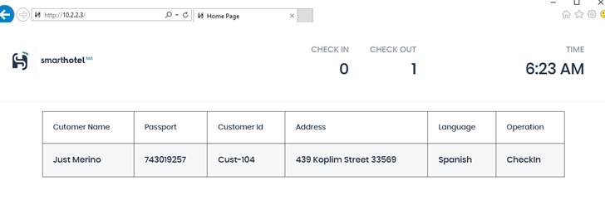

Power off domaincontroller1 & confirm domain auth is still valid

**Exercise targets**

1. Ensure all available VMs are migrated
2. Post-migration tasks complete on each VM
3. Migrated application is accessible and displaying correctly from Hyper-V Host